EWI MONTHLY MEETING NOTICE

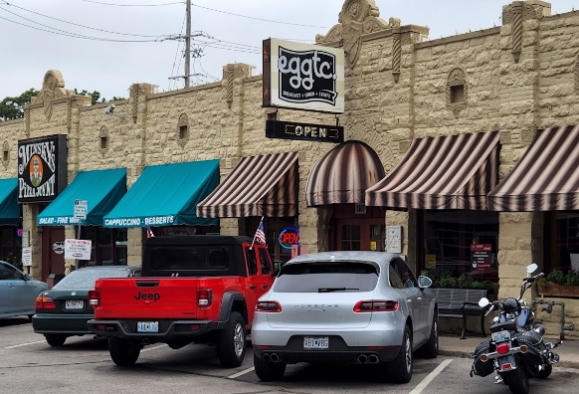

Wednesday, December 13, 2023
Eggtc.
5107 Main St, Kansas City, MO 64112
(816) 561-0116
Networking: 5:30 P.M. – Networking

Dinner: 6:15 P.M.

Sack It For Santa: We will be collecting teen gifts and cash donations for member firm Fox4’s Love Fund Sack It For Santa program. Use the link below to donate cash or shop the wish list. Otherwise, just bring your donations to the meeting! Let’s help make the holidays brighter for 2,000 area teens. https://www.fox4lovefund.org/santa

Program: Optional Gift Exchange
After the meal we will have a fun gift exchange. To play, bring a wrapped gift
worth a maximum of $20 (unisex preferred).

Menu: Assorted Pizza, House Salad & Breadsticks, Cream Cheese Pesto Dip with Pita Wedges, and Chocolate Chip Cookies.

Reservations: Please RSVP to ewikansascity@gmail.com no later than Friday, 12/8.
Be sure to include the names of any guests.

Meeting fees are $35.00 per attendee/$30.00 per Sustaining/Life Member. Mail checks to Joy Neill, Price Chopper, 7600 State Ave., Kansas City, KS 66112 or pay online at www.ewikcchapter.org or give your payment to Joy at the meeting.
If you have any dietary restrictions or need to cancel, please email laura.bird@compass-usa.com

