

EWI MONTHLY MEETING NOTICE
Wednesday, November 15, 2023

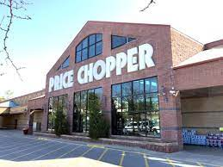
Price Chopper
7000 W. 75th St., Overland Park, KS 66204

Networking: 5:30 P.M.

Dinner: 6:15 P.M. Mo’ Bettahs Hawaiian Style Food
We will enjoy regular boxed lunches (menu on following page) with up to 2 choices of meat on a bed of cabbage. Served with 1 choice of rice (2 scoops), 1 choice of salad, 2 sauce cups, and 4 small kine cookies. PLEASE PROVIDE YOUR FOOD SELECTIONS WHEN YOU RSVP.

Program: 7:00 P.M. Philanthropy – Ronald McDonald House
We will assemble 25 or more Protein Snack Kits with shelf stable items like protein bars, tuna packets, beef jerky, peanut butter packets, etc. Following the menu, please see the list of suggested items and what we have secured so far. Let us know by the RSVP deadline what items and quantities you or your member firm would be willing to donate. Also looking for a volunteer to deliver the kits.

Reservations: Please RSVP to ewikansascity@gmail.com by Friday, November 10. Please Note: if you RSVP and later cannot attend, you are still responsible for the meeting fee as we will have paid for you. Thank you!
Total amount enclosed $_______ (or give to Joy Neill at the meeting)
$35.00 per Active Member/Guest; $30 Life Members. Free for first time guests/potential members!

Name: _________________________________ Member firm: ______________________________________

I will___ won’t___ attend the meeting. I will bring ____guest(s).
Guests/Names:_____________________________________________________________________________

Payment: Mail checks to Joy Neill, Price Chopper, 7600 State Ave., Kansas City, KS 66112 or pay online at www.ewikcchapter.org

If you have any dietary restrictions or need to cancel, please email laura.bird@compass-usa.com
Menu: Please provide your selections when you RSVP
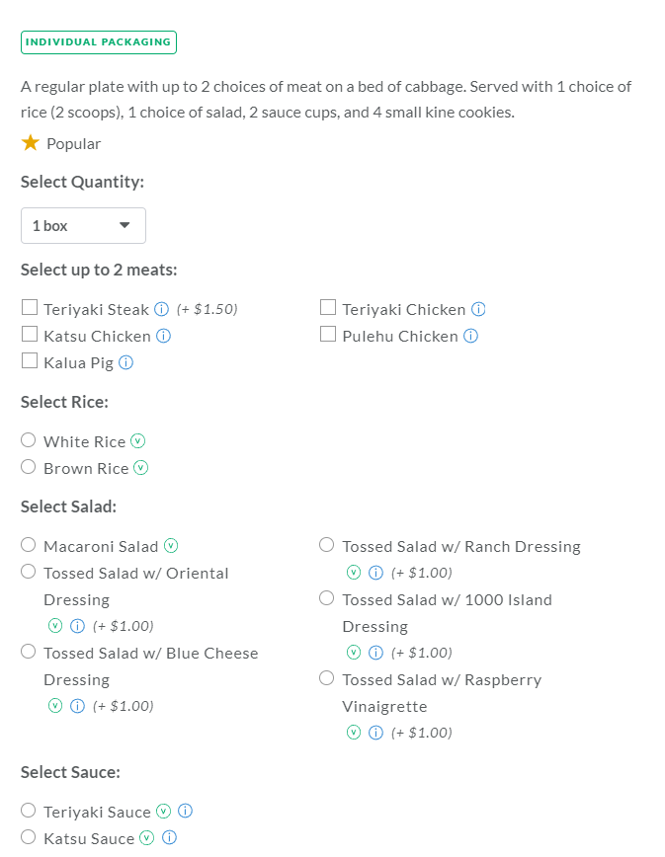

PLEASE SEE THE FOLLOWING PAGE FOR INFORMATION ON THE KITS

We want to prepare at least 25 kits, more if we have sufficient donations. Below are some suggested items and some donations already secured. Large Ziploc bags will be provided Please let us know what item(s) and how many of each you can bring. We would also appreciate a volunteer to drop off the kits at the location below.

Create Protein Snack Kits
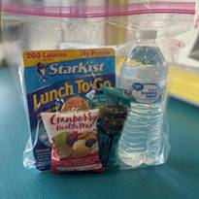
Our families are on the go! Help us provide a healthy and filling snack that will keep our families fueled through a long day of appointments and/or procedures. Please include individually packaged, non-perishable items only.

Item suggestions:
Beef jerky
Protein bars (Pure Protein, Clif Bars, Quest): CK will supply 25
Individual peanut butter packets
Tuna packets
Trail mix: CK will provide 25
Bottled Water: CK will provide 25

Drop off location:
Longfellow House
2502 Cherry St.
Kansas City, MO 64108
Hours: 7am-7pm, 7 days a week

